**Kedir Nasir Omer Date: Nov. 28/2022**

**UC SanDiego- Big Data Specialization**

1. **Data Exploration**

# Overview of the Data Set

# 

* The available files are listed in the table below, along with a brief summary of what can be found in each one.

|  |  |  |
| --- | --- | --- |
| **File Name** | **Description** | **Fields** |
| ad-clicks.csv | Database of clicks on ads | timestamp: when the click occurred.  txId: a unique id (within adclicks.log) for the click  userSessionid: the id of the user  session for the user who made the click  teamid: the current team id of the user who made the click  userid: the user id of the user who made the click adId: the id of the ad clicked on  adCategory: the category/type of ad clicked on |
| buy-clicks.csv | Database of purchases. | timestamp: when the purchase was made.  txId: a unique id (within buyclicks.log) for the purchase  userSessionId: the id of the user session for the user who made the purchase |

|  |  |  |
| --- | --- | --- |
|  |  | team: the current team id of the user who made the purchase  userId: the user id of the user who made the purchase buyId: the id of the item purchased  price: the price of the item purchased |
| game-clicks.csv | A record of each click a user performed during the game. | timestamp: when the click occurred. clickId: a unique id for the click.  userId: the id of the user performing the click.  userSessionId: the id of the session of the user when the click is performed.  isHit: denotes if the click was on a flamingo (value is 1) or missed the flamingo (value is 0)  teamId: the id of the team of the user  teamLevel: the current level of the team of the user |
| level-events.csv | A record of each level event for a team. Level events are recorded  when a team ends or begins a new level | timestamp: when the event occurred.  eventId: a unique id for the event teamId: the id of the team |

|  |  |  |
| --- | --- | --- |
|  |  | teamLevel: the level started or completed  eventType: the type of event, either start or end |
| team-assignments.csv | A record of each time a user joins a team. | timestamp: when the user joined the team.  team: the id of the team userId: the id of the user  assignmentId: a unique id for this assignment |
| team.csv | A record of each team in the game. | teamId: the id of the team name: the name of the team  teamCreationTime: the timestamp when the team was created  teamEndTime: the timestamp when the last member left the team  strength: a measure of team strength, roughly corresponding to the success of a team  currentLevel: the current level of the team |
| user-session.csv | A record of each session a user plays.    When a team levels up, each current user session ends and a | timestamp: a timestamp denoting when the event occurred. |
|  | new session begins with the new level. | userSessionId: a unique id for the session. userId: the current user's ID. teamId: the current user's team.  assignmentId: the team assignment id for the user to the team.  sessionType: whether the event is the start or end of a session.  teamLevel: the level of the team during this session.  platformType: the type of platform of the user during this session. |
| users.csv | Database of the game users | timestamp: when user first played the game.  userId: the user id assigned to the user.  nick: the nickname chosen by the user.  twitter: the twitter handle of the user. dob: the date of birth of the user.  country: the two-letter country code where the user lives. |

# Aggregation

|  |  |
| --- | --- |
| Amount spent buying items | $ 21407 |
| Number of unique items available to be purchased | 6 |

* A histogram displaying the frequency of purchase for each item:

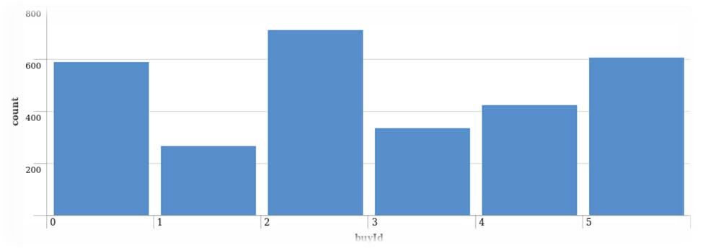

* A histogram displaying the revenue generated by each item:

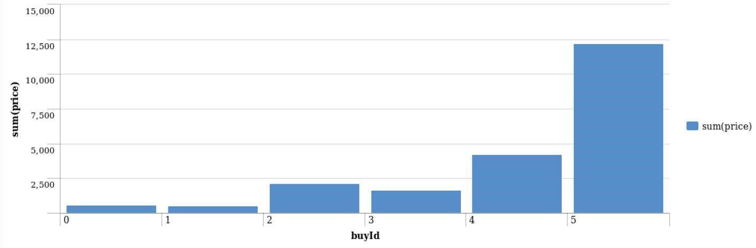

# Filtering

* A histogram of the top ten users' combined spending amounts (ranked by how much money they spent).

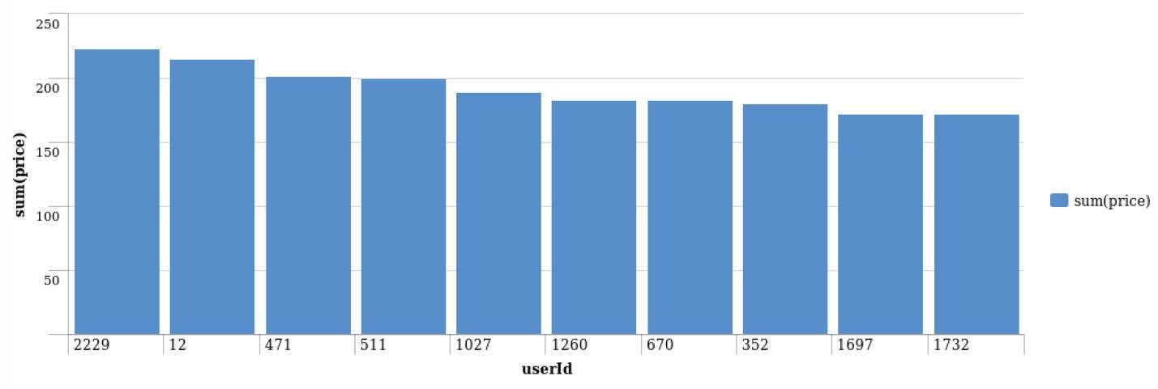

* The following table shows the user id, platform, and hit-ratio percentage for the top three buying users:

|  |  |  |  |
| --- | --- | --- | --- |
| Rank | User Id | Platform | Hit-Ratio (%) |
| 1 | 2229 | iPhone | 11.5% |
| 2 | 12 | iPhone | 13% |
| 3 | 471 | iPhone | 14.5% |